Company ScottishPower

Student/Degree: Molly Henman – BSc Geography

Manager: Kate McGeoch

Project Title: Engaging a diverse workforce in the breadth and depth of the sustainability agenda

Project details
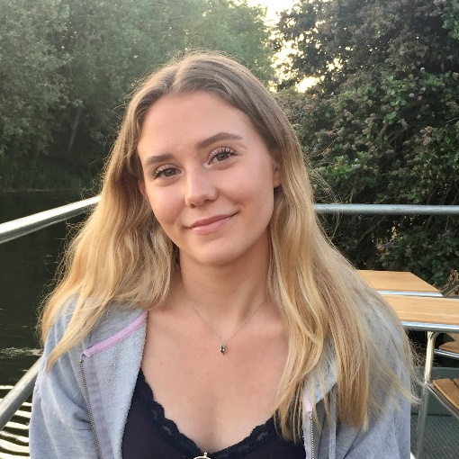
This project involved three main areas:

- Develop a self-service intranet site that acts as a one-stop for information about our team, what we are working on, important compliance documents, and previous communications pieces
- Collaborating to deliver a week-long programme of in person, online and interactive events in our Sustainability Festival
- Creating engaging, relevant, and relatable blogs to be circulated to the entire staff body

Results
Intranet site – creation of a 35-page intranet site with over 110 links to documents and websites as a one-stop for our team. It became the second most interacted with page in first month it was live with 700+ hits.
Sustainability Festival – 10 events were delivered over the course of the week engaging our entire staff body across numerous sites. Events included a photography competition and a swap shop for clothing items.
Blog posts – 4 blogs were published internally and circulated to the workforce of over 6000. These blogs improved awareness of sustainability and our team and increased engagement with our content. My first blog became our most successful in terms of engagement to date.

What have you gained from your placement?
During my time at ScottishPower the skills that stand out to me that I have learnt are teamwork and how to implement feedback on a level that is not attainable outside the workplace. My IT skills have dramatically progressed, and I particularly value the experience of using a content management system when developing our team intranet site. I am also proud of, and grateful for, the network I have grown by confidently reaching out to others and will continue to utilise into my final year of study and beyond.

Company Managers Statement
Our team has a key role to play in raising awareness of sustainability across the whole company. This year Molly has been integral to achieving this aim with her project ‘Engaging a diverse workforce in the breadth and depth of the sustainability agenda’. Her work developing the self-service intranet site and on delivering on internal communications campaigns such as the Sustainability Festival has raised the sustainability profile and the work of our team across the group. That Molly has been able to assimilate diverse information, develop through lines within and across blogs and produce succinct, high-quality copy suitable to be presented to our 6000 staff is to be celebrated, as the high-level skills that Molly has brought and acquired to do this are rare in early career professionals. Kate McGeoch

