Company: Skelly & Couch

Student/Degree: Alicia Neal-Useche/Civil or Architectural Engineering

Manager: Steve White

Project Title: IES Help Manual

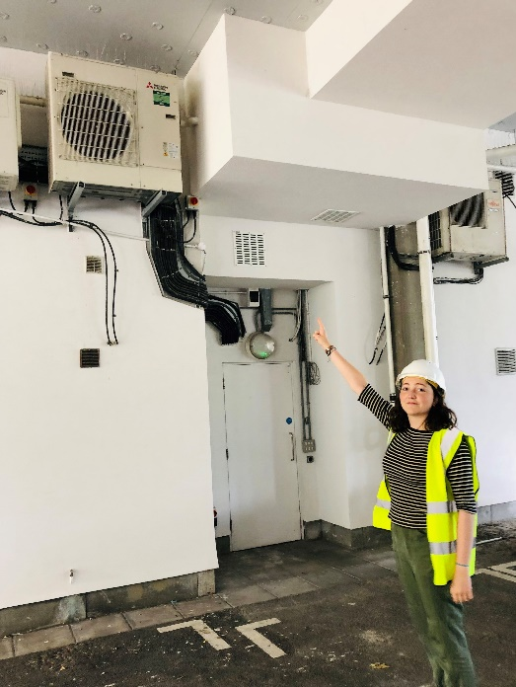
Project details: I created the IES Help Manual as an instruction manual to condense the company’s knowledge of the IES VE* software into one place, making it easy to access, navigate, and understand, thus making the software easier and quicker to use, and more accessible to learn. IES VE is a dynamic simulation software which is used around the office for various types of analyses, calculations, and building modelling.

Results: The manual has helped engineers at the company to cut down on time when using IES by providing useful tips, step-by-step instructions, clear answers to common questions, and straightforward solutions to issues and errors that often arise while using the software. Previous notes have also been updated, organised, and made more understandable, ensuring the knowledge compiled by other engineers in the past is not lost.

Using my extensive knowledge of the IES software, I have also been able to personally give advice, solve queries with other engineers’ models, and work on models for multiple projects, freeing up hundreds of hours of chartered engineers’ time and allowing them to work on other outputs and projects, generating substantial additional revenue for the company.

One of the main outcomes of the Manual is its potential for use in the training of new engineers, which will be very useful as the practice grows in the coming years, as well as its use for more senior engineers to easily learn to use IES if they haven’t before, often the case due to its daunting complexity. The Manual will also be helpful for experienced engineers to be able to easily pick up new IES skills, as the software is capable of doing a large number of different analyses and calculations, and even the most experienced users often encounter new things to learn about it.

What have you gained from your placement: My placement has helped me to develop immensely in the professional environment, giving me invaluable technical skills and knowledge that I will be able to apply in the future, both at university and in the working environment beyond. My year here has also allowed me to develop soft skills that are transferable across my personal and professional life alike, such as problem-solving, time management, communication skills, and teamwork. However, I would say that my greatest gain over this year has been a great boost in my self-confidence, such that I now believe much more in my abilities, in my knowledge, and in that I am capable of doing and achieving great things, both as an engineer and as a human being.

Company Managers Statement:
Alicia’s contribution to the business in the last year has been exceptionally highly valued by myself personally, but equally by all of the directors of Skelly and Couch. In her time with us so far, Alicia has become a key member of our sustainability and thermal modelling team and a highly valued member of our team of engineers, regarded as an equal and with her skills being consistently in demand. The Manual is only one of a number of extremely valuable contributions that Alicia has made that will lead to our increased ability to design sustainable buildings far after her work is finished. Her presence in the office brings a calmness and gentle humour to all our days, and her dedication and reliability is exemplary. We have offered Alicia the opportunity to stay with us for a further year and were delighted when she agreed to stay. Steve White - Director

