Company PCS Instruments

Student/Degree: Benedict Cunningham-Walker – Pre-University

Manager: Tom Welham

Project Title: CAD Redraws and BOM Management

Project details
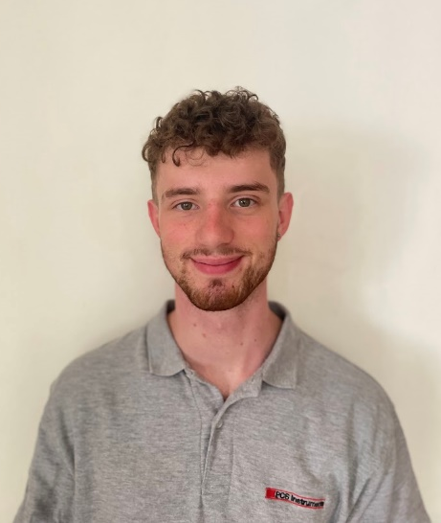
At PCS Instruments, my role in the R&D department focused on CAD modelling, assembly, and structuring of thousands of parts used in laboratory instruments for fuel and lubricant analysis. Alongside my core CAD work, I actively engaged in diverse projects involving electronics, chemical research, project management, and design to broaden my knowledge and contribute to the company's multifaceted needs.

Results
Through meticulous CAD redraws, I ensured accurate and detailed data for over 6,000 assemblies and parts. This comprehensive dataset was vital for PCS's software, driving functions such as purchasing, sales, and stock control. Additionally, my research project involved designing and developing a bespoke component that enabled PCS to conduct measurements under challenging conditions. By refining the manufacturing process and utilizing innovative tools, we successfully produced over 20 prototypes in just four weeks. The resulting component surpassed design requirements and enhanced PCS's ability to develop high-value, low-volume instruments while saving significant manufacturing time.

What have you gained from your placement
One of the most important experiences I gained was an insight into the entire development chain, from idea generation to supplier coordination, it broadened my perspective and honed my skills in engineering research. Collaborating with PhD students furthered my passion for research and confirmed my decision to pursue mechanical and electrical engineering studies at Bath University. Overall, this placement provided me with valuable experiences, enhancing my personal and professional growth while setting a solid foundation for my future career.

Company Managers Statement
Ben's submission for the contribution to business award highlights his exceptional work throughout the year. His high-quality and detailed tasks, along with his enthusiastic attitude, have made him an integral part of our team. His outstanding performance on the CAD redraw and bills of materials project, involving intricate electromechanical assemblies, has been meticulous and diligent. This project will enable automated stock control and facilitate future engineering changes. Additionally, Ben's methodical approach in developing a bespoke mechanical component for a new instrument has opened doors for new tribological research. His numerous R&D projects and overall contribution to the company have exceeded expectations, making him highly valued and respected. We will miss him greatly when his placement ends.

