Company AnTech

Student/Degree: Brett Hoffmann - Mechanical engineering

Manager: Jenny Bentley, Chris Bowmer

Project Title: Vibration response of Components Down-Hole

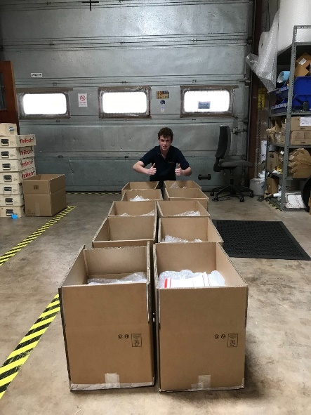
Project details
My project formed a key part of the company's equipment development program, to enable further business expansion in the field of Coiled Tube Drilling. I undertook the critical task of reworking the main sensor on the drill, valued at £35k, which is instrumental in categorizing directional drilling as a distinct operation. I tasked myself with finding a solution to prevent this sensor from failing to vibration. The discontinuation of previous sensor versions meant that the success of the company's future drilling operations hinged on my design. By outperforming competitors, my design has the potential to significantly increase success rates and eliminate downtime, the company was discarding one of these sensors after each drilling campaign due to vibration issues.

Results
I successfully resolved the sensor failure, resulting in substantial cost savings of £75,000 per drilling campaign for the company. Additionally, I introduced Finite Element Analysis (FEA) to the company's testing processes, offering significant advantages over in-house testing. This implementation will prove immensely beneficial in terms of accuracy and efficiency. Towards the end of my tenure, an issue arose with the original vibration table, necessitating repairs that would have taken 12 weeks and incurred costs close to £12,000. Taking ownership of the situation, I proactively sourced a refurbished unit that not only matched the repair cost of the original but also boasted significantly enhanced power. Moreover, the replacement had a minimal lead time of just 2 weeks, ensuring minimal disruption to operations.

What have you gained from your placement (one paragraph)
Working in various roles within an engineering company has given me a first-hand understanding of how each role contributes to the overall system. My experience in production has enhanced my practical engineering skills, while design and FEA have provided invaluable knowledge applicable to my university studies. The administrative aspect of my role has strengthened my soft skills, time management, and traceability training for accurate record-keeping. Effective budget planning was essential due to significant equipment expenditures. This experience has not only been educational but has also improved my time management, leadership, and communication skills in a professional setting.

Company Managers Statement
Brett’s project to rework the directional sensor on the BHA to survive the harsh environmental conditions it experiences while drilling has been vital in making improvements to our equipment and therefore improving the tool reliability and subsequently improving the efficiency of the team. His approach has demonstrated a great level of maturity and organisation, proven by his ability to take responsibility for his work. He is a very self-propelled individual, who has thought ‘outside of the box’ and has realised the importance of documenting his progress. He has taken on the responsibility comfortably and has demonstrated huge potential for a future career in engineering and product development.

