Company Leonardo UK

Student/Degree: Henry Labrow

Manager: Stephanie Cairney

Project Title: A Sophisticated 3D Graphics Renderer

Project details
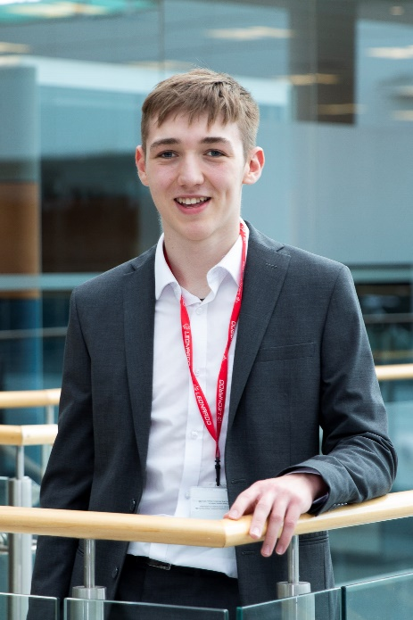
The aim of my project was to build a new 3D graphics renderer from scratch using an updated application programming interface (API) known as modern OpenGL. I aimed to display smoother, more customisable and higher quality graphics than the previous renderer.
Later in the project, I completed a number of stretch goals. These included integrating my renderer into the existing toolset, adding animation capability, and creating a variety of new diagnostic visualisations.
This technology assists productivity by providing visualisations of technical problems as well as new avenues for data visualisation.

Results
My work has already contributed to multiple important projects. The render time for large models has been reduced by ~90x whilst the quality of the graphics has greatly improved. This makes diagnostics of 3D results much easier and gives way to new tools which require real time rendering.

As an example, an existing route planning tool was updated with my 3D graphics code. This allows for rendering of complex terrain in a 3D environment, as well as animation of the vehicle routes planned in the tool, which gives context to the scene and permits a deeper understanding.
Another tool I contributed to was an innovative modelling tool, which made use of my graphics for displaying results. The results from this tool rely on understanding a complex 3D geometry, and so are very difficult to represent or understand in 2D forms. I was given a Company award for this work and its contribution to a classified project. My work will also be a part of a submission to next year’s Leonardo Innovation Awards.
My work will be included in the next release of my team’s software package, allowing it to be used both internally at Leonardo and externally by a large and diverse customer base.

What have you gained from your placement?
I have learned a tremendous amount during my placement at Leonardo Edinburgh. I have a much better understanding of the day-to-day experience of an engineer, and my ideas about working in industry have substantially changed. My ability to program in C# and my knowledge of large software development processes will be an asset for the rest of my career. On top of this, my approach to problem solving, my teamwork and my confidence have greatly improved – I feel much more comfortable working with a small team and providing input to help solve complex engineering problems.

Company Managers Statement
Henry is the tenth Year in Industry student to work within our small three person team, and is the second student I have supervised directly. Henry has been a highly valued member of our team over the past year and we have all enjoyed working with him. He has done outstanding work on his own project and his help has been invaluable in the progression and success of other projects within the team.

