Company Saint-Gobain Formula

Student/Degree: Meshach Tang – MEng Chemical Engineering with Industrial Study

Manager: Sam Maskery/Emma Culverhouse

Project Title: Plant Air Usage Management

Project details
Reducing plant-wide compressed air consumption and leaking has been a key focus, cutting required electricity demand from compressors as global energy prices skyrocket. During my project, I have:

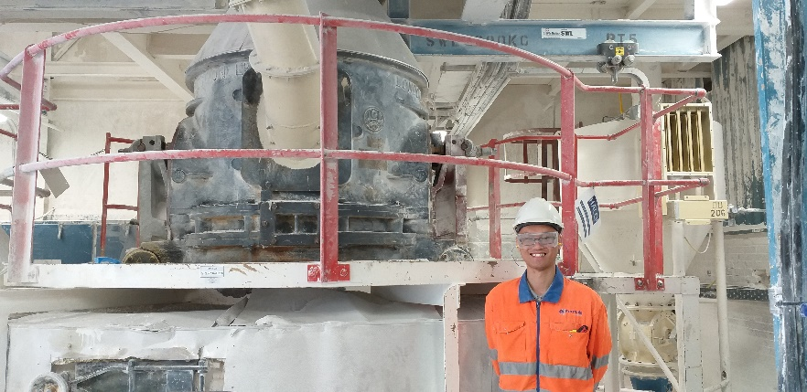
- Conducted a compressed air system leakage audit of the site to diagnose leaks
- Developed a programme to prioritise and address identified leaks
- Monitored air trends and collated relevant usage data via graphs, identifying areas of concern within the plant
- Developed a design for a SCADA dashboard tracking shift air consumption
- Promoted awareness of reducing compressed air usage for production, engineering and management staff

Results
- From the air leakage audit, nearly 190 leaks were diagnosed. My targeting programme has ensured that 85% of leaks have been fixed, with new parts installed to modernise the plant.
- There has been a tangible reduction in air consumption rate, with a 54% decrease in average compressed air flowrate. My project has led to reducing the electricity consumption of the compressors per tonne of product produced by 11%.
- This has resulted in a saving of over £50,000 from previously wasted compressed air.
- A consistent air usage monitoring system has been fully implemented, with senior managers regularly using information to inform business and project decisions.

What have you gained from your placement?
From this project, I have learnt how to achieve deliverable outcomes in a business setting. In particular, setting out clear action plans and schedules have been key to ensure the project runs smoothly. My placement has enabled me to be more competent for future work in engineering. Not only have my problem solving and organisation skills been enhanced, I have also gained invaluable experience in leading projects, in particular communicating with different stakeholders.

Company Managers Statement
Having previously gone through similar struggles with gaining buy-in from all departments, what Meshach has been able to achieve with this project is commendable. Personally, I have seen the shift in attitude from multiple departments to this issue, which has typically been viewed as very low priority, and hope that this change is what will help us maintain the success that Meshach has achieved through this project after he has gone. For the business, the cost savings achieved will be substantial and will aid us in meeting our energy targets in future. – Sam Maskery

